RevA 03 Janvier 2012

CCB process with JIRA – Setup information

Pre-requisite: an Orchestra V5.1 (or later) client and a JIRA server installed and upgraded with TCM_1.0.2 or later

A- Make sure that you have installed the Orchestra JIRA connector plugin on your JIRA server (ref. SCOM ConnectorJira):

a/ To install the Orchestra JIRA connector plugin, copy the file orchestraservices-<version>.jar from your jira connector installation folder (e.g. C:\Orchestra\Thales\ConnectorJIRA\utils\orchestraservices-3.5.jar) into your JIRA Data installed plugins folder (e.g. C:\Orchestra\Atlassian\JiraData\plugins\installed-plugins\.)

b/ Restart your Atlassian Jira service

B- Create in Jira the following filters (used in the CCB report document generation with Mozart):

0- All PROJ Processed during CCB (Filter Id1)
project = getOrcString("PROJ", " JIRA Project key?") AND "Decision description" ~ getOrcString("CCB 30-08-2011", "CCB label?")

1- All PROJ Accepted during CCB (Filter Id2)

project = getOrcString("PROJ", " JIRA Project key?") and "Decision description" ~ getOrcString("CCB 30-08-2011", "CCB label?") AND status = Accepted

2- All PROJ More info required during CCB (Filter Id3)

project = getOrcString("PROJ", " JIRA Project key?") and "Decision description" ~ getOrcString("CCB 30-08-2011", "CCB label?") AND status = Analysed and "Internal priority" = "More info required"

3- All PROJ Postponed during CCB (Filter Id4)

project = getOrcString("PROJ", " JIRA Project key?") and "Decision description" ~ getOrcString("CCB 30-08-2011", "CCB label?") AND status = Analysed and "Internal priority" = postponed

4- All PROJ Rejected during CCB (Filter Id5)

project = getOrcString("PROJ", " JIRA Project key?") and "Decision description" ~ getOrcString("CCB 30-08-2011", "CCB label?") AND ((status = Closed and "Closure reason" = rejection) OR (status = Rejected))

5- All PROJ Closed during CCB (Filter Id6)

project = getOrcString("PROJ", "JIRA Project key?") and "Decision description" ~ getOrcString("CCB 30-08-2011", "CCB label?") AND (status = Closed and "Closure reason" != "Rejection")

Note: In all those filters, replace the default project PROJ with one of your existing CHARM project name (this is for test purposes only). Those filters are generic and should not be run from the JIRA interface. They are used to automate the CCB report generation in Mozart and have been designed to be run from the Engineering Desk with 2 filter parameters “Project key” and “CCB label” that are setup through an Engineering Desk service. Thus the filters are never modified and can be used for all the CHARM projects that have been declared in JIRA.

C- Create in JIRA for each project the filters that will be used during the CCB meeting + setup the ToDo list (or Pending list) and Submitted list filters:

All PROJ - Problems to discuss
project = PROJ and status = analysed and type = "Problem Report"

All PROJ - Enhancements to discuss
project = PROJ and status = analysed and type = "Enhancement Request"

All PROJ - Requests to close
project = PROJ and status = Verified

My pending list
project = PROJ and assignee = currentUser()

My submitted list
project = PROJ and originator = currentUser()

Note: In all those filters, replace the default project PROJ with your own JIRA project name.

D- The required CCB report Artifacts and Data scripts are available in this zip file: 
- Unzip this file on your file system

then

- Update the .jira artifact file (located in Artifacts\Jira\.) with your JIRA server url information and rename the .jira file with your JIRA server name (e.g. if your Jira host name is “host1” then your JIRA artifact file name should be renamed host1.jira and the content of the file should be : serverurl=http://host1:8080 )

E- For the Engineering Desk, unzip the file 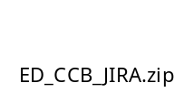into your Project desk folder (on your file system) then import and load the ED_CCB_JIRA Engineering Desk project:

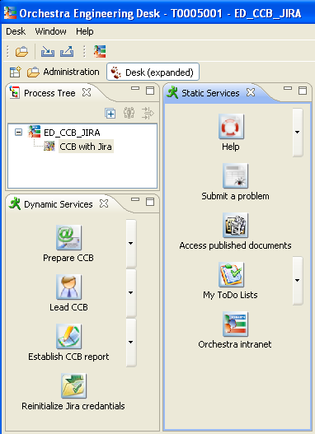

F- Then update the value of your Engineering Desk variables according to your own environment information:

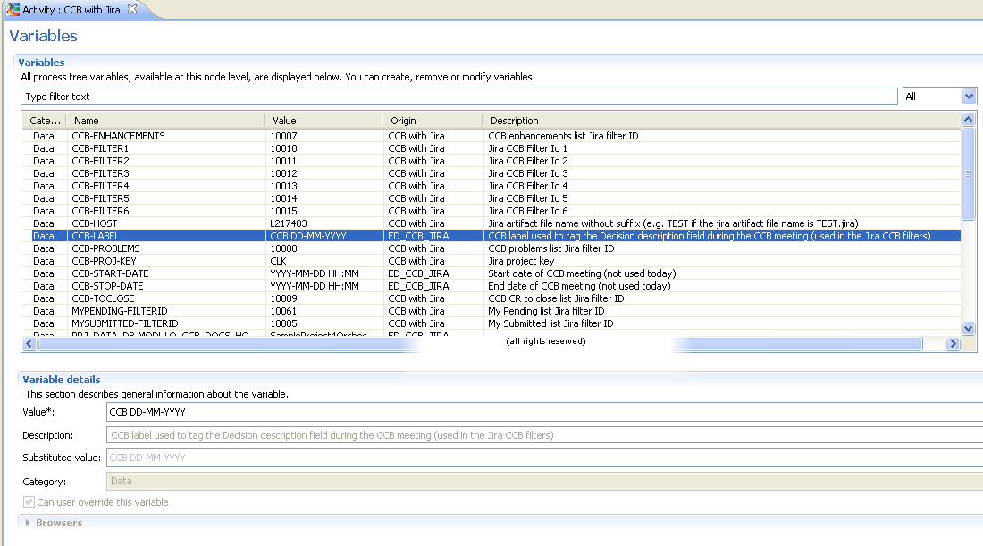

Warning: the Engineering Desk variable CCB LABEL shall be defined at project level (at top project level, not activity level) with the box “Can user override this variable” checked.

G- Customise the CCB report Mozart template for Jira:

a/ Launch Mozart and open the Mozart project called CCB_REPORT_JIRA (located in Artifacts\Projects\.)
b/ Drag and drop the artifacts ConfigurationManagement/CCB/CCBBroadcastList and ConfigurationManagement/CCB/CCBReport from your Mozart Artifacts explorer into your Mozart fragments view. You can also customise the Synthesis section of your report by adding some metrics defined in your JIRA System Dashboard for example:

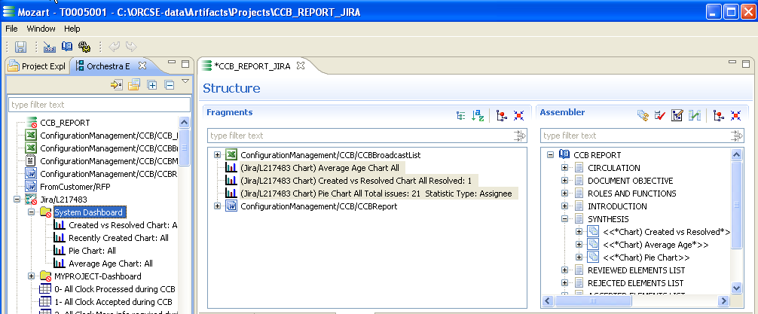

Then save the Mozart project CCB_REPORT_JIRA as a template in your Mozart project template folder (e.g. C:\ORCSE-data\Config\5.0.1\Mozart\ProjectsTemplates\.) :

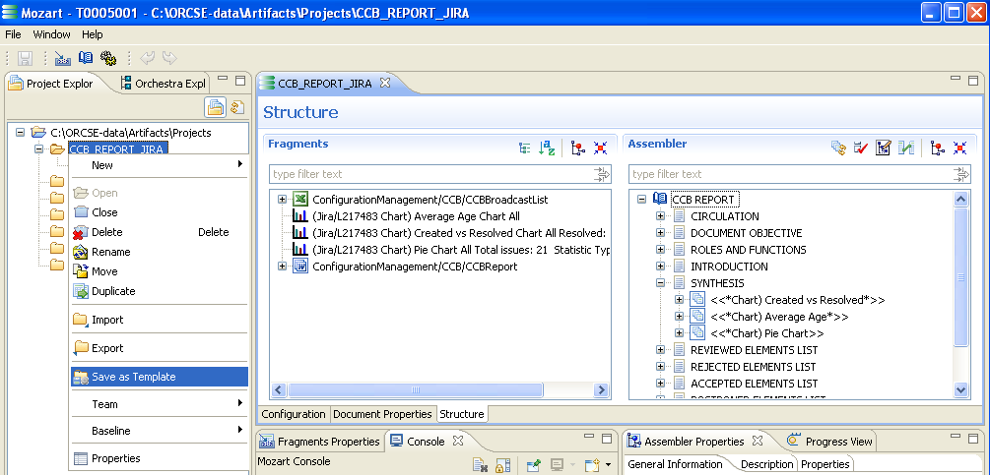

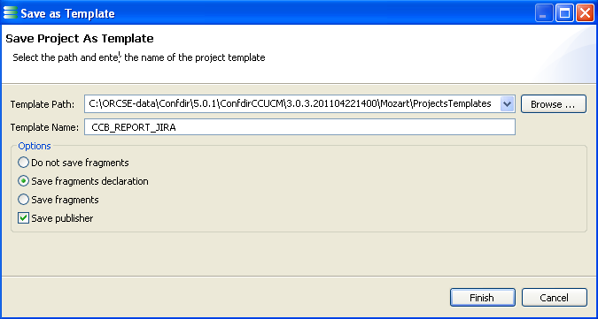

That’s all!

Note: To perform the CCB process, please follow the instructions defined in the Work instruction CCB process with CHARM on JIRA.
Warning: You must use a user perspective “Desk” or “Desk expanded” (not the “Administration” perspective) to test the Engineering Desk CCB process services since the Administration perspective always uses the default value of the Engineering Desk variables.

